Database: Applied Science & Technology Source

Step 1: Go to the Subject Guide: Computer Science & IT https://seneca.libguides.com/computerscience

Step 2: Go the tab: Databases & Journals.

Select the database: Applied Science and Technology Source.

Step 3: Search for an article Tip: Use the AND operator.

* + Type web design the first search box.
  + Type shopping in the second search box. Hit Search.

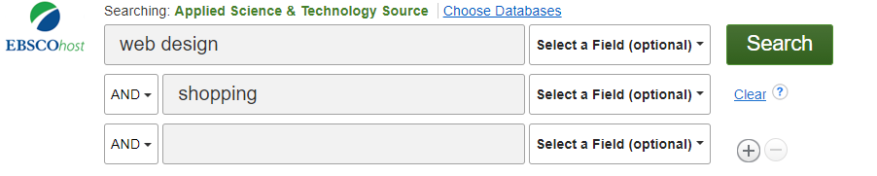

Step 4: Find the article (approximately #3)



Step 5: Circle the correct answer:

* How many authors? 2 4 6
* Does the article include the research methods? Yes or No
* Are there references at the end of the article? Yes or No
* How many participants were recruited for this study? 17 30 48
* Is this a scholarly journal article? Yes or No

Congratulations! You completed your Applied Science & Technology database search.